

User
Manual
Aitor Albendin
Cristian Sosa
Yaritza Aburdene
Institut
Carles
Vallbona
índex
1. Introduction 1
2.Use and operation of the application 2
2.1 User profile 2
Home page 3
About hotel 3
Services 4
Contact 5
Register 5
2.2 Registered user/Customer 7
Login 7
Profile 8
How to make reservations 9
2.3 User worker 13
2.3.1 Managment of tasks 13
2.3.2 User receptionist 16

1. Introduction


The application «Ocean Hotel» was created with the objective of making hotel reservations easily and intuitively. Also asked to make the internal management of the hotel (workers, tasks, rooms, reservations, etc ...)
This application consists of three type of users:
- Guest user
- Registered user / client
- User worker.
This user manual will explain step by step how to use the application for all users.

2.Use and operation of the application

2.1 User profile

The guest user is unregistered and user can view the following pages:
- Home
- About hotel
- Rooms
- Services
- Contact
- Order list
- Login/Register

Home page
This is the homepage showing a carousel of images of the hotel and a short description of the hotel with a button that redirects to a page on the hotel. It also shows a description of the three services of restaurants. You can see in the footer links to the page, the list of rooms, social networking buttons and the logo of the hotel.
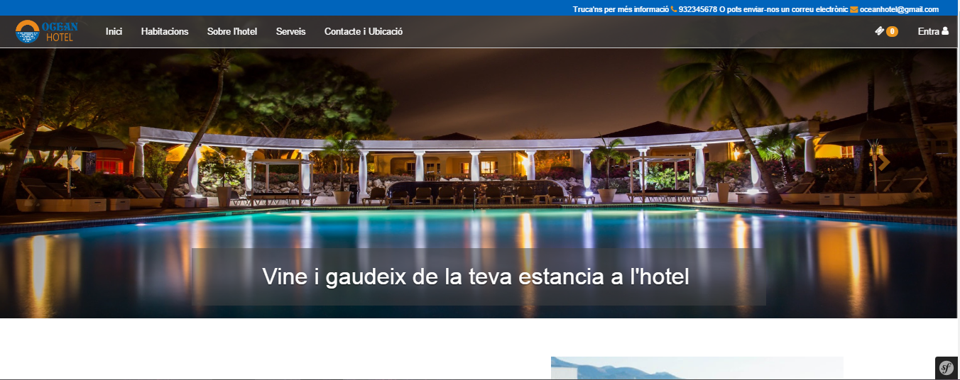

About hotel
On this page you can see a description and pictures of the hotel and facilities.
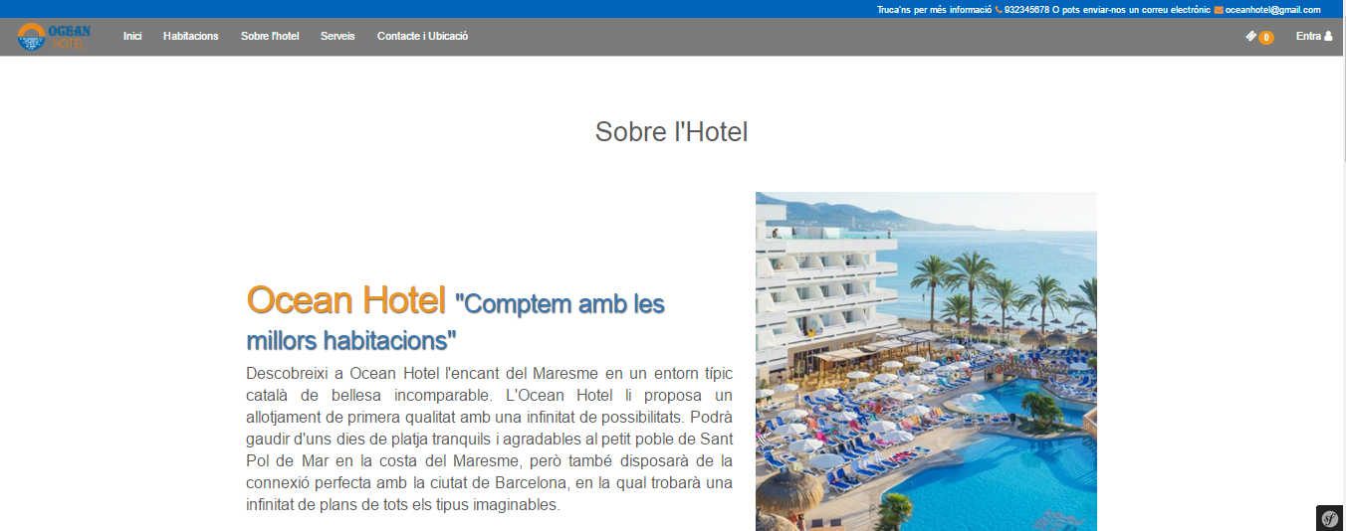

Rooms
On this page you can see all the available rooms with filters to search by name the type of rooms and dates.
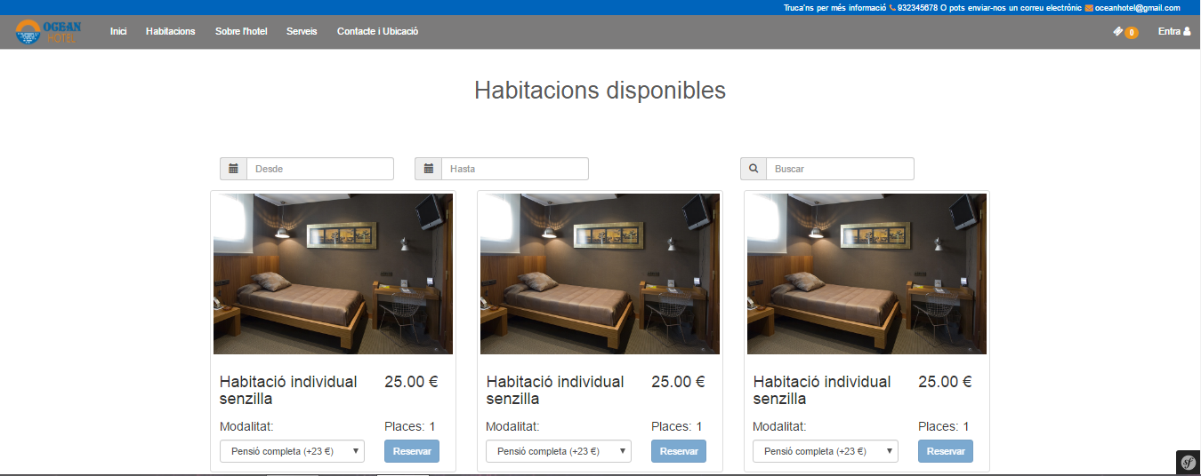

Services
In the services page you can see the services offered by the hotel when making a reservation.
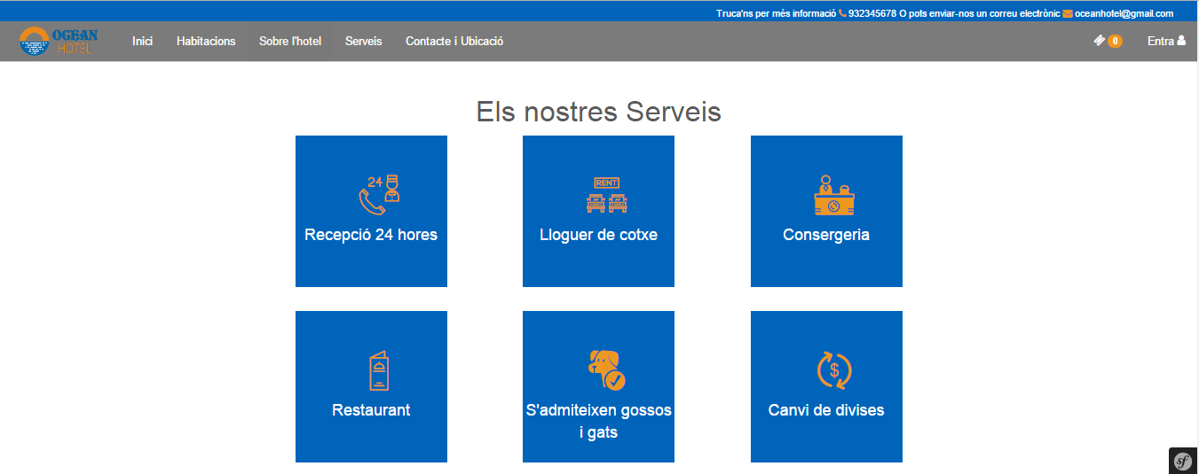

Contact
This page has a contact form where the user can ask for information if have any doubts. Also on this page provides a map showing the location of the hotel.
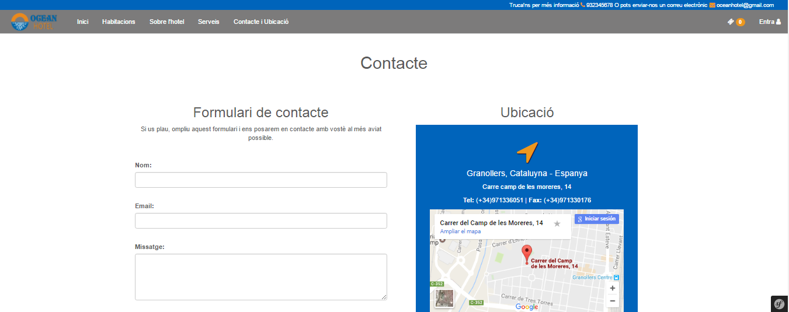

Register
The customer has the possibility to register as a user to make a reservation of a room.
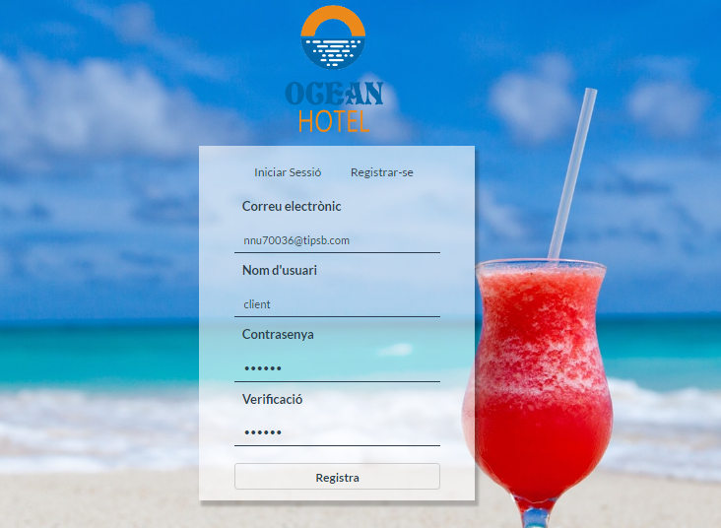
By registering you receive an email to activate your account s'usuari.
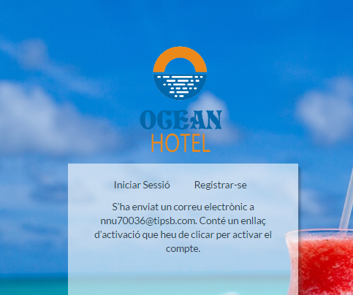
And this is the e-mail:
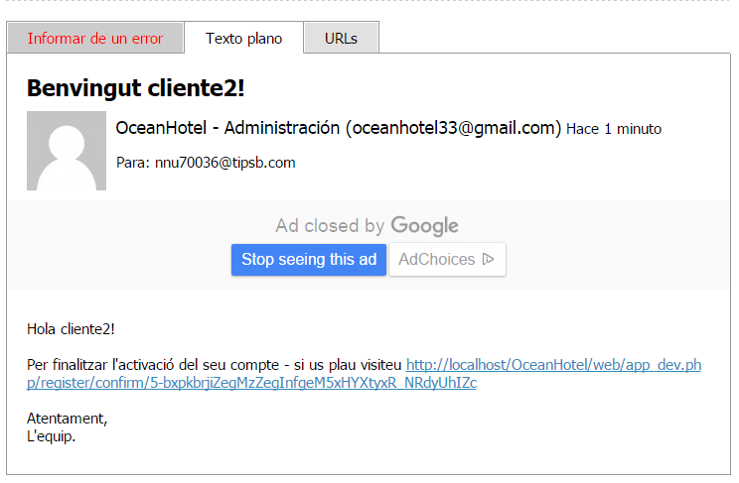

2.2 Registered user/Customer

Login
To place an order must be logged on as a user.
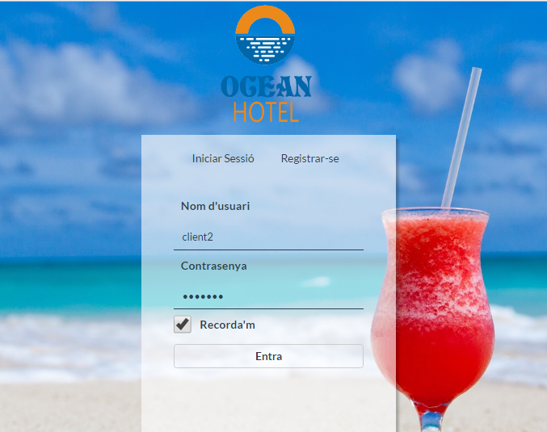
User in session:
The registered user can access your own profile, and can view their reserves.
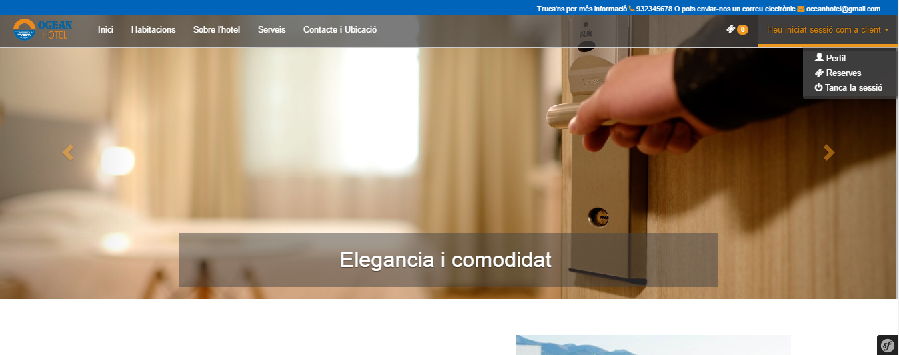

Profile
The user can view their profile and change your data.
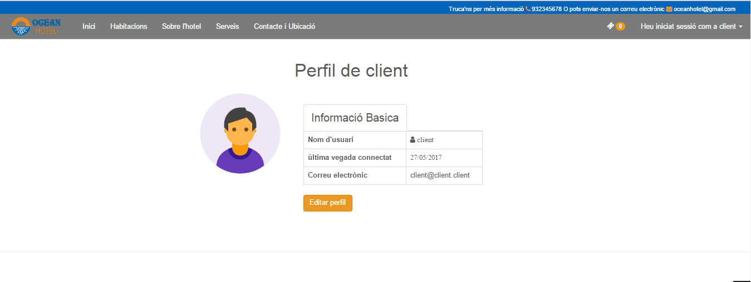
The user can change their username, email and require the password to confirm the changes.
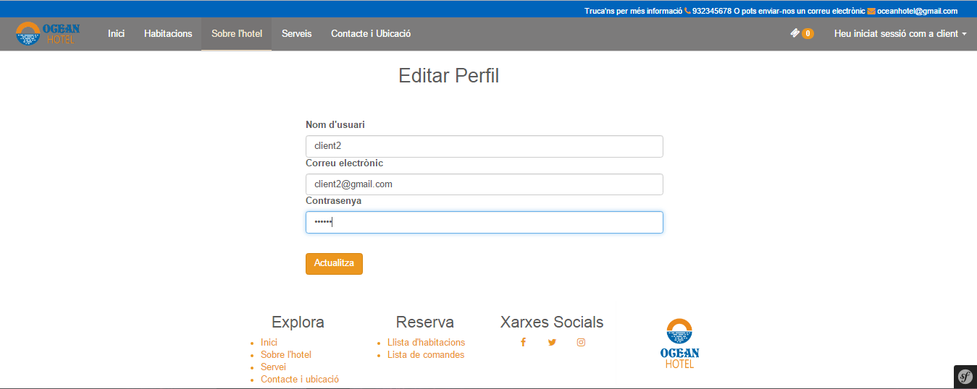

How to make reservations
To place your order you must select a date arrival and a date departure.
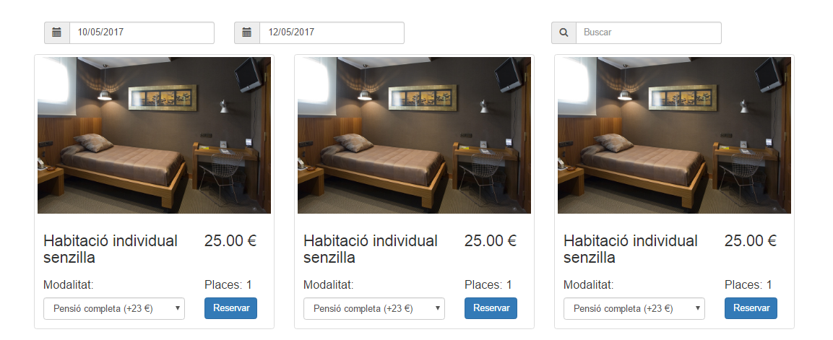
The date of entry can not be greater than the output.
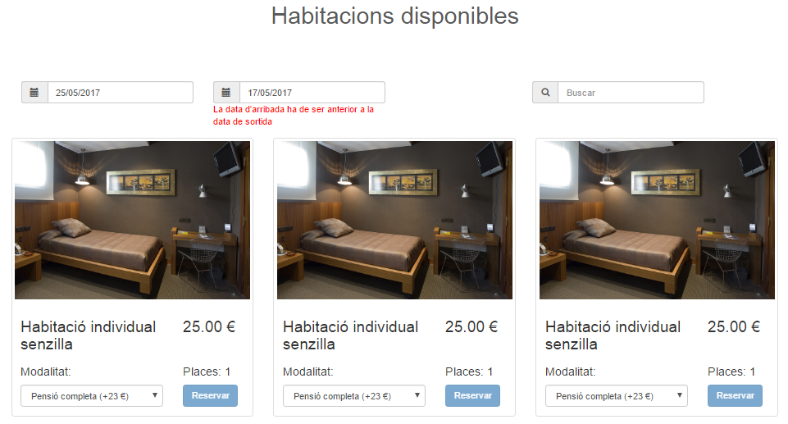
Once you have selected the correct date and the room can make the reservation.

Booked, added to the list in order.
The list command displays the complete information of the room before booking. You can delete or keep adding rooms on the same reservation with the selected data.
It is also estimated price per bed, per day and adds modality.
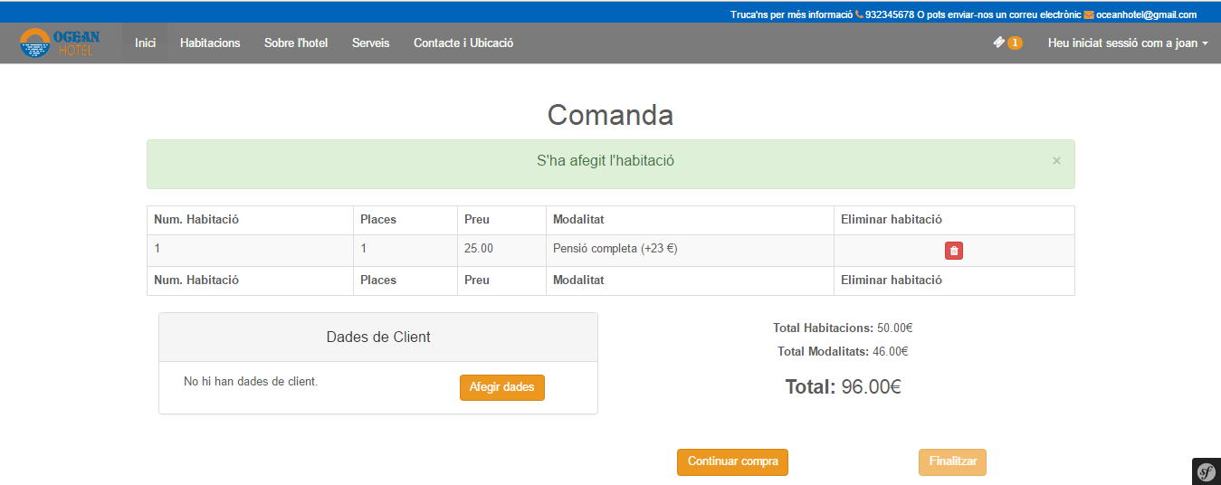
If you want to select other dates first be removed before the rooms added.
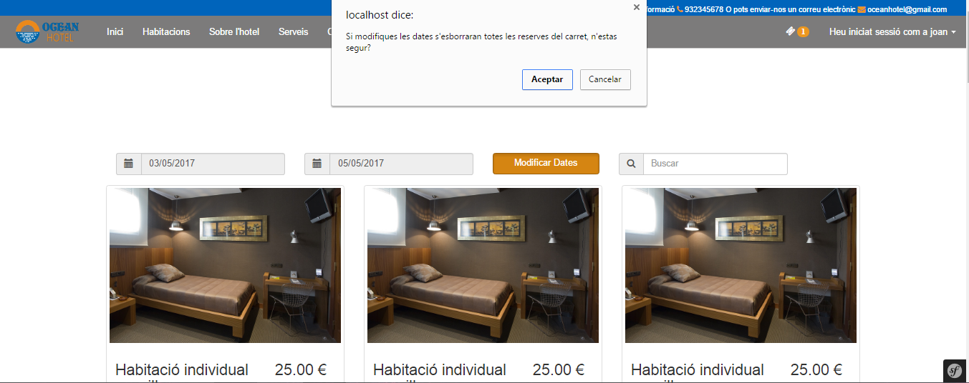
To finally an order, must add client data.
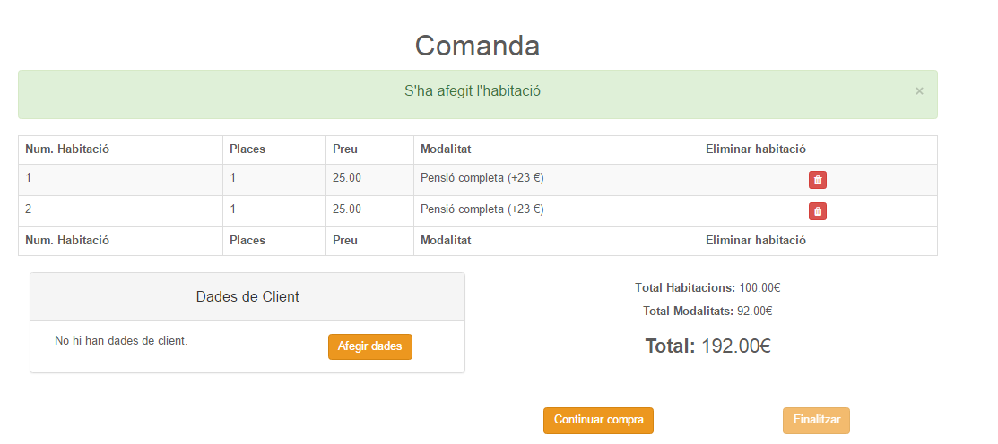
Customers should add their data to the client form.
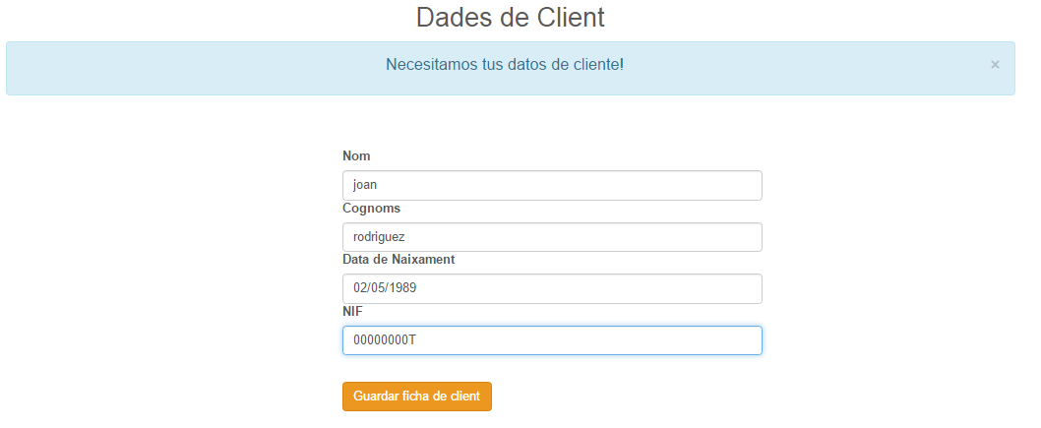
We have already made a booking.
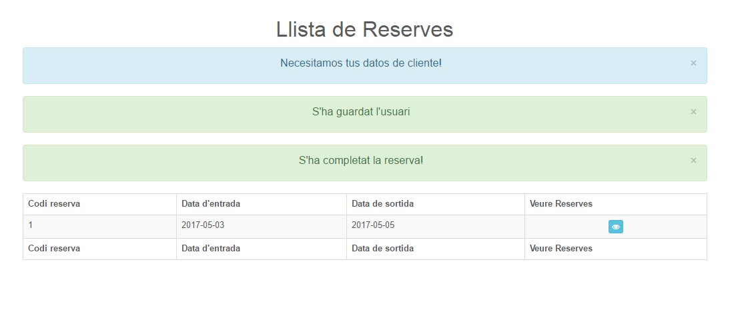
Te user can check your reservations.
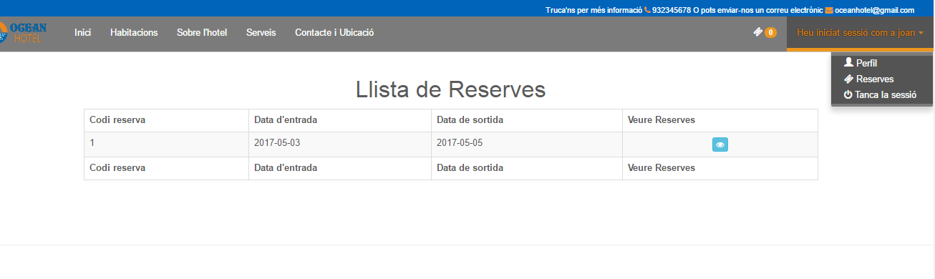

2.3 User worker
The user must first register as employee user. After the administrator is responsible for assigning the role of worker type.

2.3.1 Managment of tasks
Once the user has the role of worker type, they can access to view tasks.
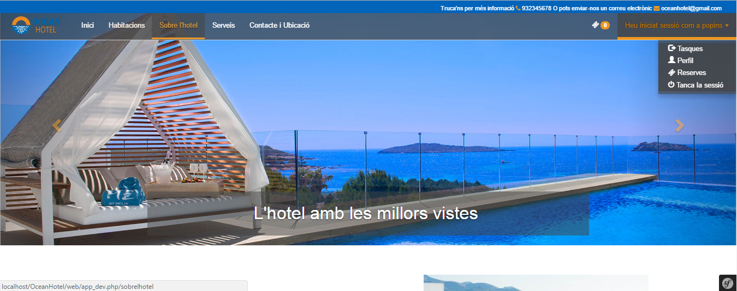
When the user accesses worker can see another interface.
The user can view pending tasks and assign that wish.
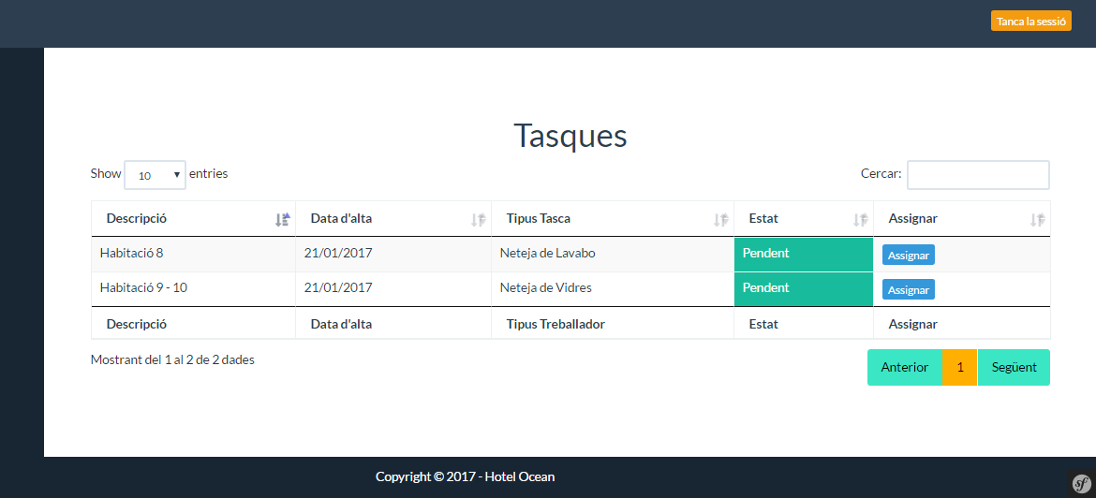
When you assign a task automatically added to pendent tasks.
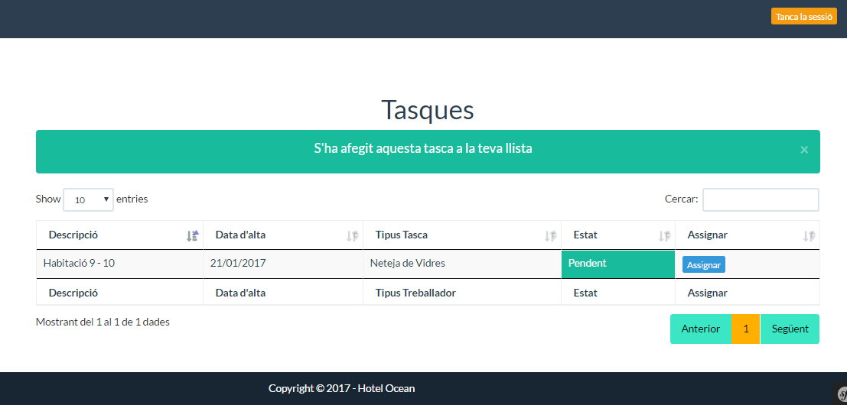

In the list, the task passed to the "Pending".
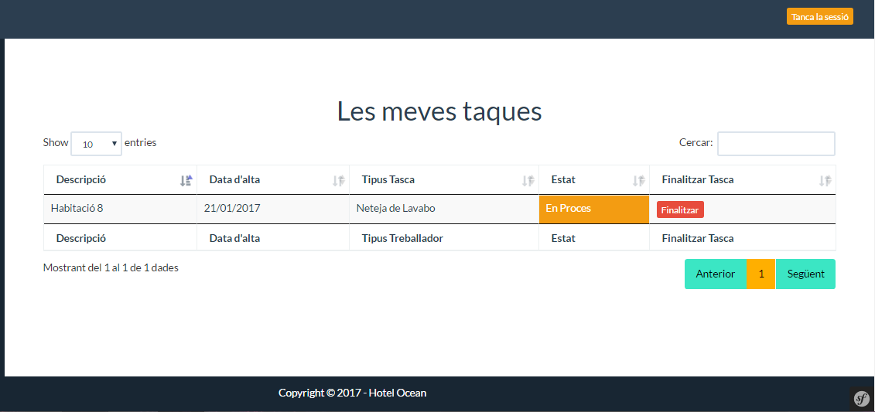
At the end of the task, as you can give end button. Be marked as completed and saved the day's work is over.
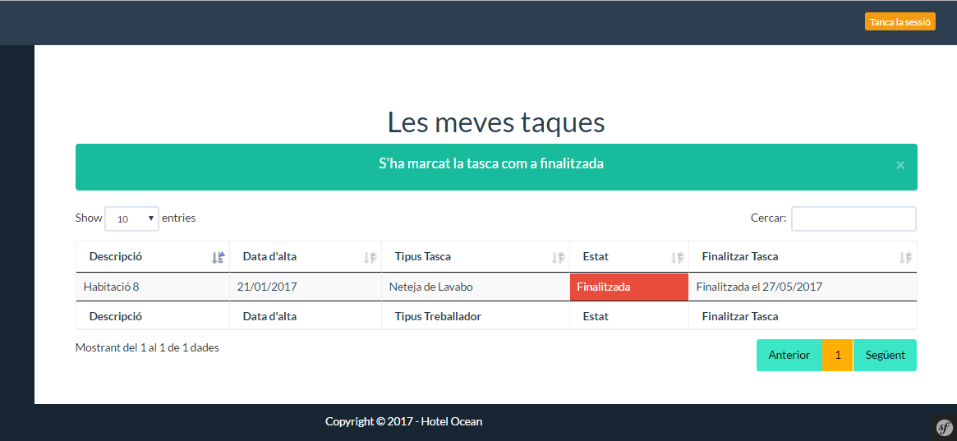

2.3.2 User receptionist
The user types a user receptionist worker. The difference is that you can access to manage reservations and customers.
They can see that there are reservations.
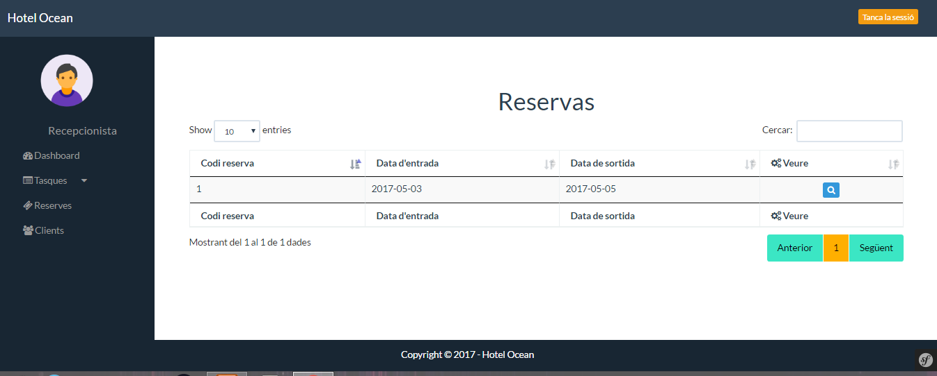
Also they can add, edit or delete customers.
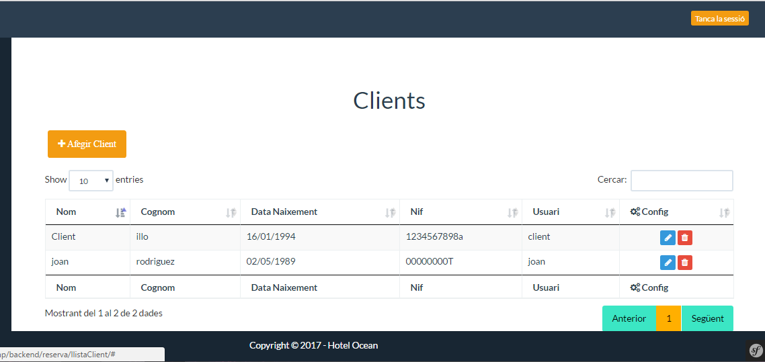

A booking can unsubscribe or remove the entire reservation.


